**Stock Market Price Prediction**

**Abstract:**

Accurate prediction of stock prices plays an increasingly prominent role stockiness market where returns and risks fluctuate wildly, and both financial institutions and regulatory authorities have paid sufficient attention to it. As a method of asset allocation, stocks have always been for by investors because of their high returns. The research on stock price prediction has never stopped. In the early days, many economists tried to predict stock prices.

This is important in our case because the previous price of a stock is crucial in predicting its future price. While predicting the actual price of a stock is an uphill climb, we can build a model that will predict whether the price will go up or down.

**Block/ Flow Diagram:**

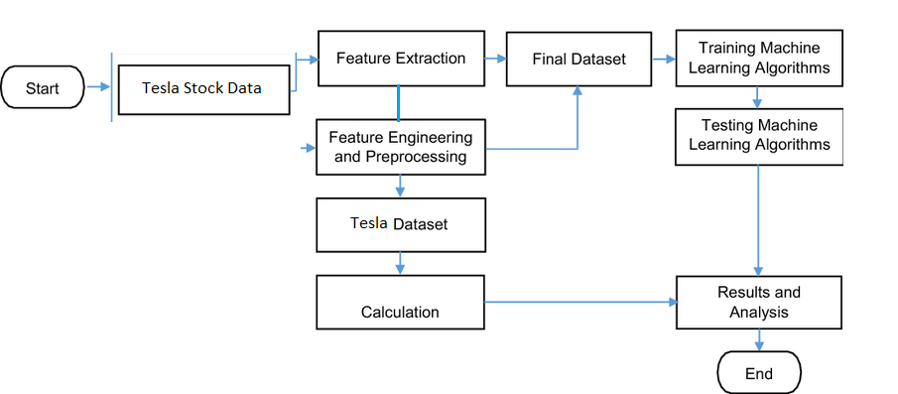

**Result:**

|  |  |
| --- | --- |
| **Parameter** | **Result** |
| 1. Model | 1. Linear Regression 2. Decision tree |
| 2.Dateset Name | Tesla |
| 3.No. column | 7 |
| 4.No. rows | 2416 |
| 5. Train Data | 1793(80%) |
| 6. Test Data | 598(20%) |
| 7. random state | 0 |

|  |  |
| --- | --- |
| Model | Accuracy_Score = (no.CorrectPrediction)  Total No. Prediction |
| Linear Regression | 0.9231588723179124 |
| Decision Tree | 0.9984202270453749 |

**Conclusion:**

In this project, we are predicting closing stock price of any given organization, we developed a web application for predicting close stock price using Linear regression and Decision tree algorithms for prediction. We have applied datasets belonging to Tesla Stocks and achieved above 95% accuracy for these datasets.